Periodic report on ENSAR-JRA05
Simulations and Analysis Tools for Nuclear Reactions and Structure in Europe (SATNuRSE)

Objectives
The nuclear structure and reaction community is at a stage in which a substantial amount of R&D work has been performed for various emerging experimental facilities but a lot still needs to be done before we are ready for the next generation experiments at medium and large-scale facilities. At the same time, one needs to prepare for the analysis of the obtained data as they become available in the coming years. We have achieved a number of goals in this direction in SiNuRSE work-package of ENSAR as is evident from the milestones and the deliverables. A platform based on the GEANT4 simulation code has been developed and can now be used for experiments foreseen at the ENSAR2 facilities. New event generators and improved physics models relevant in the energy domain of ENSAR2 facilities have now been implemented in GEANT4 and specific “physicslists” created. Expert members of the community know how to deal with databases and working examples have been developed to show how all this would work. Some members of SiNuRSE have become members of the GEANT4 collaboration, which is very important to make sure that the needs of the nuclear physics community will be taken into consideration. We now need to take further steps to advance our simulation tools, in particular in the domains defined further in this project and also to come up with new tools which are essential for the analysis of the events. These developments have to be done within ENSAR2 to maximize the output of the efforts which will be spent on these issues as the developers are also members of the experimental collaborations within ENSAR2.

The work-package is divided into four tasks:

Task 1: deals with the development of physics models, event generators and their benchmarking and validation,

Task 2: deals with the development of analysis tools,

Task 3: data management,

Task 4: dissemination of knowledge and workshop organization.

Several groups have been in the process of hiring the personnel to start the work. Many have already started the work to see how to maximize the efficiency of the work-package. Here, we only report on the concrete results achieved until now.

Subtask 1.1: Improvement and validation of neutron transport models in GEANT4 at neutron energies below 20 MeV (CIEMAT)

The following activities have been realized in the report period:

- Production of the TENDL libraries released with the last GEANT4 versions. These libraries have to be used with G4ParticleHP.

- Production and testing of the new ENDF/B-VII.1, JEFF-3.3 and JENDL-4.1 libraries, currently under validation. These libraries will be distributed on the GEANT4 cross-section data website at IAEA. https://www-nds.iaea.org/geant4/

- Production, validation and publication of a break-up model of ¹²C for GEANT4. This model is of great relevance for the simulation of organic neutron detectors (plastic, solid and liquid scintillators) and diamond detectors and is going to be part of the future standard GEANT4 releases. A paper has been published on this topic.

Subtask 1.2: Extension/improvement of the INCL physics models (CEA)

The intra-nuclear cascade model, INCL, modelling nucleon and, thanks to ENSAR/SiNuRSE, light-ion induced reactions in the 100 MeV-3 GeV energy domain, has become a reference in the field, and is available in GEANT4 [1]. However, further improvements and extensions are still needed in order to allow the code to be universally used in the simulations of experiments or to address specific reaction channels that will be studied in the community of ENSAR2. Two lines of improvement have been identified in SATNuRSE: the introduction of strange-particle production channels for the simulation of experiments on hypernuclei and the improvement of the model in light-ion induced reactions in the domain of few particle-removal channels which are important for both simulation of nuclear structure experiments and medical applications for prediction of the β+ emitter ¹¹C used in carbon therapy.
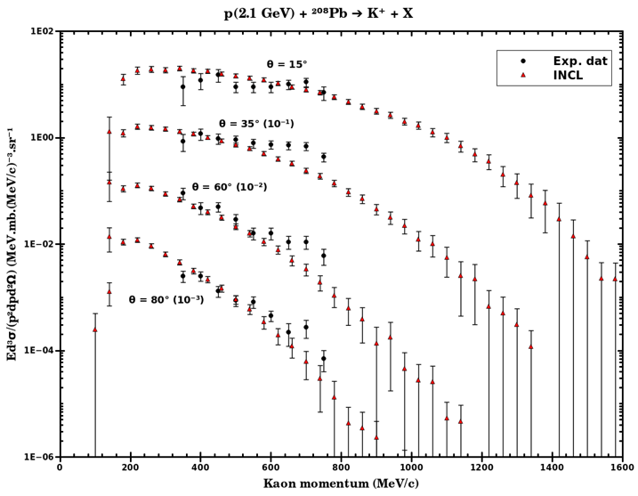
Fig. 1: Example of comparison of the new version of INCL to experimental data on kaon production.

- Introducing strange-particle production channels for the simulation of experiments on hypernuclei

The production of strange particles (kaons and hyperons) and hypernuclei in light charged-particle induced reactions in the energy range of a few GeV has become a topic of active research at several facilities (e.g., HypHI and PANDA at GSI and/or FAIR (Germany), JLab (USA), and JPARC (Japan)). In this subtask, strange-particle production channels, i.e. kaons and light hyperons, are introduced in INCL in order to allow the model to be used for simulations of experiments studying hypernuclei, in particular in R3B and Super-FRS at the future FAIR facility.

INCL, known to give good results up to 2-3 GeV, was recently upgraded by implementation of multiple-pion emission to extend the energy range of applicability up to roughly 15 GeV [2]. Addition of strange-particle production channels implies as a first step to implement for each channel: i) the relevant elementary cross sections (production, scattering, and absorption) and ii) the characteristics of all the particles in the associated final states. Although some of those ingredients are already used in models of the same type (e.g., Bertini, GiBUU), we decided to compile, update, and validate the necessary information. The elementary ingredients that we adopted are based as far as possible on experimental data. However, unfortunately this can be done only for a few channels. Therefore, hypotheses and models were necessary. Nevertheless, an intensive use of isospin symmetry enabled us to determine a large number of ingredients. In addition, a critical analysis of those ingredients and comparison with other models was performed in order to better understand the results of INCL calculations involving strange particles. Fig. 1 shows preliminary results of INCL for kaon emissions in the reaction p(2.1 GeV)+²⁰⁸Pb. They are encouraging. The first step is, therefore, considered as completed and an article describing the parameterization of all the considered channels is being written and will be submitted to a journal in November.

In a second step, INCL will be validated on all the available experimental data on kaon and hyperon production from interaction of light charged particles with nuclei and compared to other models. Finally, it will be implemented into the GEANT4 transport code before the end of the year. This work is part of the PhD thesis of J. Hirtz funded by the University of Bern under the supervision of J.C. David from CEA.

This work was presented at the JRJC (Journées de Rencontre des Jeunes Chercheurs) in 2016 (https://indico.in2p3.fr/event/13330/contributions/13787/) and at the 22nd Geant4 Collaboration Meeting – 25-29 September (University of Wollongong, Australia)
http://geant4workshop-2017.com/geant4-collaboration-meeting/

- improving the predictive power of the model in light-ion induced reactions in the domain of few particle removal channels

Concerning the few-particles removal channels and light-ions induced reactions and following the work done in [3], INCL was improved using Hartree-Fock-Bogoliubov calculations to describe the matter and energy densities in the nuclear surface. These calculations were used to obtain a more realistic description of the radial-density distributions of protons and neutrons, as well as the excitation-energy anti-correlation at the nuclear surface due to quantum effects and short-range correlations. The improvement was performed for all nuclei between proton and neutron drip lines. The new parameters describing the nuclear surface were included in INCL following our previous prescriptions based on a basic shell model.

The results of this new approach, together with standard INCL calculations, are compared with experimental data of one-nucleon removal cross sections in Fig. 2.

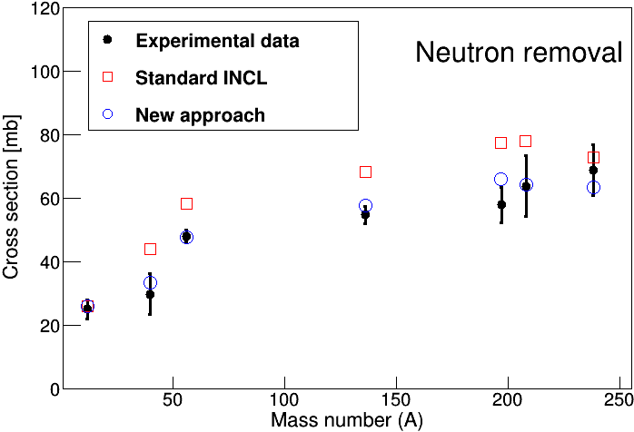
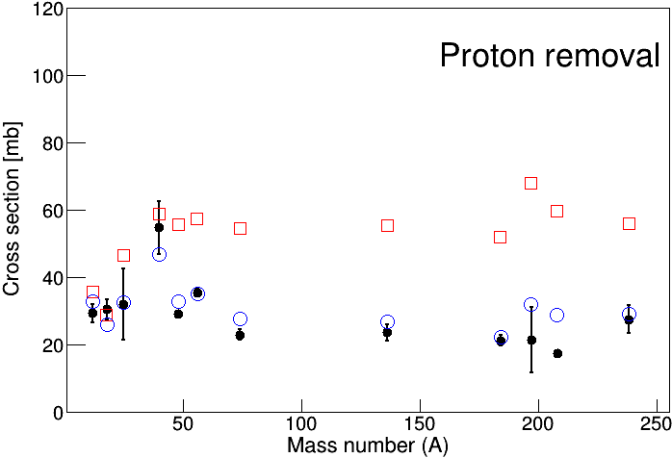

Fig. 2: Comparison of the new approach and the standard INCL calculations with experimental data of one neutron (left) and one proton (right) removal cross sections.

As can be seen, the new description of the nuclear surface allows us to improve the predictions for this observable. The new approach also improves the description of the isotopic cross sections of the heaviest nuclear residues and the total reaction cross sections for nucleon and light-ion induced reactions on nuclei. An example is shown in Fig. 3, where we compare our new model and the standard one with experimental data of carbon-induced reactions on different Neon isotopes.

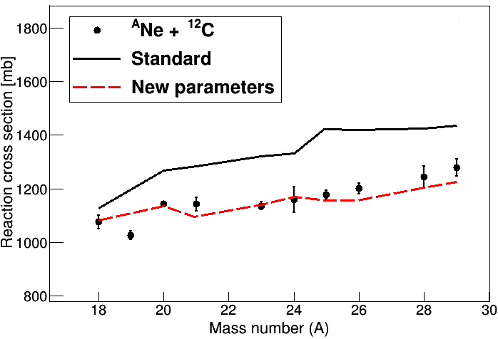

Fig. 3. Total reaction cross sections for different neon isotopes impinging on a carbon target at 950A MeV. Lines correspond to different calculations.

The publication including these improvements was submitted to Physical Review C and is under review. A proceeding for the FAIRNESS 2017 workshop (https://indico.gsi.de/event/5035/) was also submitted to Journal of Physics Conference Series. The last step will be to implement the new version into the GEANT4 transport code, which could be performed at the end of the year.

This work was performed mainly by J.L. Rodriguez-Sanchez, postdoc hired at CEA in the framework of ENSAR2.

[1] D. Mancusi, A. Boudard, J. Cugnon, J.-C. David, P. Kaitaniemi, and S. Leray, Phys. Rev. C 90, 054602 (2014).
[2] S. Pedoux and J. Cugnon et al., Nucl. Phys. A 866, 16-36 (2011).
[3] D. Mancusi, A. Boudard, J. Carbonell, J. Cugnon, J.-C. David, and S. Leray, Phys. Rev. C 91, 034602 (2015).

Subtask 1.3: Inclusion of modern atomic-interaction routines in GEANT4 (JLU)

The present-day implementation of heavy ion penetration through matter in GEANT4 deserves some improvements. The goal of this subtask is to implement a consistent description that yields accurate and precise results for stopping powers, energy losses, energy-loss straggling, range, range straggling and angular straggling of swift heavy ions in matter, that covers the complete energy range up to ultra-relativistic projectile energies (100 keV/u up to 450 GeV/u) for all projectiles and target elements. These efforts are based on an improved version of the existing code ATIMA, which is based on relativistic Bohr and Lindhard-Sørensen (LS) theories [1] at high energies (above ~30 MeV/u), and the ongoing activities comprise several steps:
- A collection and compilation of existing world-data for heavy-ion stopping;
- The analysis, development and improvement of theoretical, semi-analytical approaches and fit formulas in the low-energy range (below 30 MeV/u);
- The development of spline functions that cover the full parameter space of projectile energies, projectile and target elements (including gas-solid differences);
- Implementation of the spline functions into GEANT.

The first two points have been accomplished and the third point is underway: the extension of relativistic stopping theories down to ~10 MeV/u, where charge-exchange reactions and charge-state distributions become important, are described in the following.

Compared to the simple Bethe-Bloch equation, we could already show that the improved theory by Lindhard and Sørensen [1] leads to a much better description at relativistic energies for high-Z projectile ions. It provides a fully relativistic solution for the scattering and even takes into account the nuclear-size effect which is relevant for Lorentz factors γ>20 and at the same time the low-energy Bloch correction. We, therefore, use this as a starting point for further improvement. In a code for fast calculation, it was implemented as a table for correction of the stopping number, ΔL(Z, γ).

For nuclear-physics experiments, usually projectile energies are not so high (<1 GeV/u) and high-Z projectiles up to uranium still carry several or even many electrons. Therefore, the projectile charge to be used in the equations is smaller than Z and must be approximated in a first step.

We have collected all available data above 10 MeV/u, largely by analysis of data measured at FRS at GSI. This was compared to pure theoretical models based on individual charge-changing cross sections as well as to parametrizations for the charge distribution. It was found that theory can predict charges well for high-Z ions (like U, Pb) down to about 100 MeV/u, for Xe down to 50 MeV/u and for Ni even to 20 MeV/u. Below these energies, parametrizations can still be used, but most older sets are based on much lower energy data and not accurate enough. A comparison for uranium projectiles is shown in Fig. 4. Using only a very simple charge formula leads to large deviations at low energies which can be overcome with direct theory plus additional corrections.
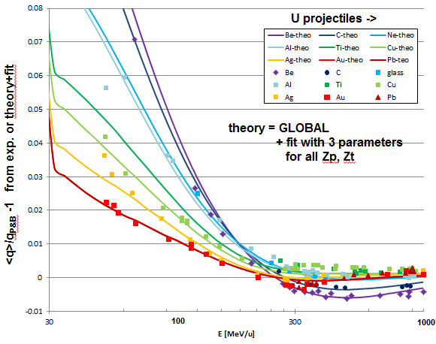
Fig. 4: Comparison of compiled measured mean charges with theory enhanced by a small empirical correction. The values are normalized to the much simpler mean charge formula by P&B [2]. The theory applied is built into the GLOBAL code [3].

As theory provides direct information on charge-changing cross sections, in a Monte-Carlo code this can be used to simulate the fluctuations of the charge state inside the penetrated matter. The statistics of these fluctuations often is the most important contribution to the fluctuations in energy loss.

Presently, these charge-state distributions and mean charges are used to develop a semi-analytical description of stopping powers, energy-loss straggling and derived quantities (such as mean ranges and range straggling), where the improved fit formulas of the mean charges are implemented in the analytical LS formulas for stopping powers and straggling; the results look very promising as they can describe experimental stopping power data down to the energy range of ~20 MeV/u with a precision of the order of ~1%; systematic studies and checks are ongoing and spline functions are calculated that cover the whole energy-projectile-target space that is available in world-wide accelerator facilities and nuclear physics experiments.

[1] J. Lindhard, A.H. Sørensen, Phys. Rev. A53 (1996) 2443.
[2] T.E. Pierce, M. Blann, Phys. Rev. 173 (1968) 390.
[3] C. Scheidenberger, Th. Stöhlker, W.E. Meyerhof, et al., Nucl. Instr. And Meth. B142 (1998) 441.

Subtask 1.4: Electromagnetic cascade model and evaporation of protons and alphas (IFIC)

The group is on the learning curve of how to further improve the codes that were developed in the past for the simulation of electromagnetic cascades.

Subtask 2.1: Implementation of physical applications (USC and FFCUL)

A complete simulation of the Lisbon setup for the ²⁷Al(p,γ)²⁸Si reactions including a gamma cascade generator from the decay of correlated gamma has been developed. The generator and the setup are now included in ENSARRoot and a report is in preparation.

We continue maintaining and improving the ENSARRoot code for different applications. During the ENSAR2 period, there has been more than 30 code commits in the ENSARRoot GitHub public repository.

Subtask 2.2: Further development of ENSARRoot code (USC, FFCUL)

A contribution about ENSARRoot entitled "EnsarRoot: The framework for simulation and data analysis for ENSAR" has been presented by Pablo Cabanelas (USC) in FAIRNESS 2017 workshop (https://indico.gsi.de/event/5035/) and the corresponding paper was also submitted to Journal of Physics Conference Series.

Regarding the use of the budget, the personnel part has been partially employed by the contract of Elisabet Galiana and the groups at USC and FFCUL foresee to finish completely the funds in March 2018, when Elisabet Galina moves to Lisbon.

Task 3: Data management protocol (RUG)

First contacts are being made between laboratories to start the inventory of their open data access.

Task 4: dissemination of knowledge and workshop organization (RUG)

This workshop will be organized at a later stage of the project.

